NDEJJE VIEW PRIMARY SCHOOL

LESSON NOTES FOR LITERACY 1 PRIMARY ONE

TERM I, II – III 2022

Theme 1: Our school:

Introduction:

*A school is a place where we go to learn.*

*My school is NDEJJE VIEW primary school.*

*The headteacher of my school is Mr. Malinga Cocas*

*Location of the school*

*Ndejje View Primary school is found in Uganda, Wakiso district, Ndejje parish Lufuka village off Entebbe road*

*People who serve us at school and what they do.*

*Many people work at school. These include;*

* *Headteacher*
* *Bursar*
* *Secretaries*
* *Cleaners*
* *Matrons*
* *Cooks*
* *Office messenger*
* *Nurses*
* *Deputy headteacher*
* *Store keeper*
* *Director*
* *Security guards*
* *Drivers*

*Roles of people at school*

* *Headteacher- Heads teachers*
* *Promotes unity in the school.*
* *Supervises the teachers and other workers in the school.*
* *Deputy headteacher: Organizes examination.*
* *Carry out other duties assigned by the headteacher.*
* *Acts in the absence of the headteacher.*
* *Teachers:*
* *Teach children*
* *Guide and council children*
* *Promote discipline*
* *Care for pupils.*
* *Bursar*
* *Collects paid in bankslips.*
* *Collects fees*
* *Banks money (fees)*
* *Pays workers*
* *Cleaners:*
* *To keep the school clean*
* *Cooks:*
* *To serve pupils food.*
* *To clean utensils*
* *To cook food.*
* *Matrons:*
* *To (takecare) of pupils at school*
* *To wash pupils clothes*
* *To clean the dormitory*
* *To teach pupils morals.*
* *Secretaries:*
* *Type exams and letters*
* *To welcome visitors*
* *Store keeper: Keeps school property*
* *Security guards:*
* *Guard the school*
* *Protect the school property*
* *Director: Plans for the school.*

*Things found in the school environment.*

*Buildings, furniture, animals., vehicles, play materials. birds, utensils,. stationery, taps, water tanks etc.*

*Uses of things found in the school environment.*

*Examples of buildings at school and their uses.*

* *Latrines: - For defecating or urinating in*
* *Kitchen – for cooking from*
* *Classroom - For learning from.*
* *Dormitories – For sleeping in*
* *Store – for keeping in food.*
* *Library – For keeping in school textbooks.*
* *Sick bay – It is where children go for medical care.*
* *Offices – It is where the headteacher , deputy, bursary and secretaries do their work from.*
* *Dining room- It is where children have meals from.*
* *Bathroom – For bathing from.*

*Examples of stationery and their uses.*

* *Books – for writing in and for reading.*
* *Pens/ pencils – For writing*
* *Coloured pencils – For shading*
* *rulers – For drawing lines*
* *Rubbers- For rubbing*
* *Papers – For writing on*

*Examples of furniture at school and their uses.*

* *Desks – For sitting at.*
* *Benches – for sitting on.*
* *Tables – For putting on books while writing.*
* *Cupboard – for keeping in books.*
* *Chairs – For sitting on.*
* *Shelves – for keeping in books.*

*Examples of utensils at school*

* *Forks, Spoons, cups, plates, saucepans and buckets.*

*Uses of other things at school*

* *Vehicles - For transporting children.*
* *Brooms - for sweeping*
* *Water tanks – for keeping water.*
* *Play ground – for playing from*
* *Tap – to provide water.*

*People who work at school and places where they work*

* *Headteacher*
* *Bursar office*
* *Deputy headteacher& secretaries*
* *Cleaners - compound*
* *Cooks – Kitchen*
* *Teacher – classroom*
* *Gatekeeper – gate*
* *librarian – library*
* *dormitory – matron*

*Things found in the classroom and their uses.*

* *Books – For writing in.*
* *Pencils – for writing*
* *Duster – For cleaning the chalkboard*
* *chalk – for writing on the chalkboard*
* *Blackboard – for writing on work.*
* *Broom – for sweeping*
* *Rag – For mopping*
* *Desk - For sitting on*
* *Table - for putting on books while writing.*
* *Shelf – For keeping in books.*
* *Bench - For sitting on.*
* *Chairs – For sitting on.*
* *Ruler – For drawing lines.*
* *Charts - For reading*
* *Rubber – For rubbing in books.*
* *Coloured pencils – For colouring / shading pictures.*
* *Calendar - For telling the date and days.*

***Activities done at school.***

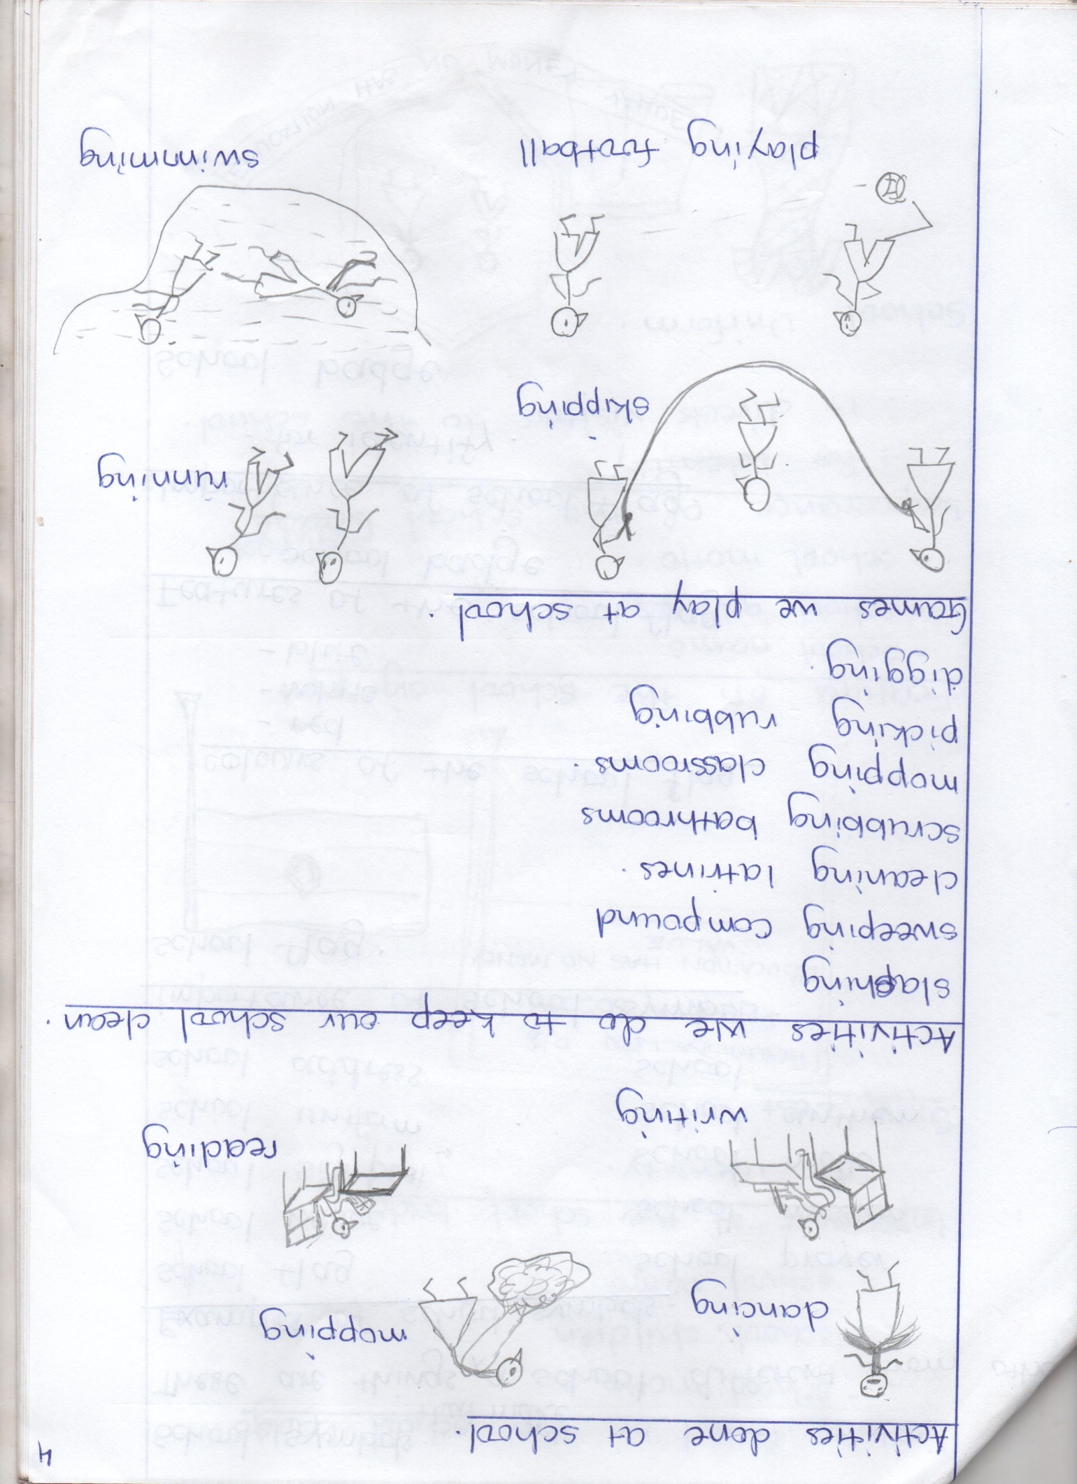

***Games we play at school***

***School symbols.***

*These are things that make a school different from others.*

*Examples of school symbols.*

* *School flag*
* *school badge*
* *School sign post*
* *School uniform*
* *School address*
* *School prayer*
* *School mission*
* *School motto*
* *School anthem*
* *School name*

*Importance of school symbols.*

*School flag.*

*Colours of the school flag.*

* *White*
* *Blue*

*Features on the school flag*

* *School badge*

*Importance of the school flag.*

* *For identity*

***School badge***

**

*Features found on the school badge.*

* *School motto*
* *School children*
* *School name.*

*Importance of the school badge*

* *For identity*

***Sign post***

*Ndejje View P/S*

*P.O.Box 6265, kampala*

*Run for a bright future*

*Features on the school sign post.*

* *School name*
* *school address*
* *School motto*

*Importance of the school sign post*

* *It directs visitors to the school*

*School uniform.*

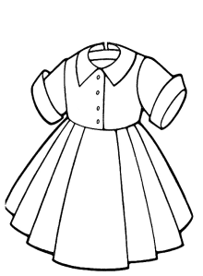

***Colours of the school uniform***

* *Blue*
* *white*

***People who wear uniforms.***

* *Pupils (school children)*
* *Police officers*
* *doctors*
* *nurses*
* *priests*
* *reverends*
* *bishops*
* *soldiers*
* *chefs*
* *pilots*

***Importance of the uniform****.*

* *It makes children look smart.*
* *For identity.*

***Ways of keeping the school clean.***

* *By removing cobwebs*
* *By picking rubbish*
* *By burning rubbish*
* *By mopping*
* *By sweeping classrooms, dormitories & compound.*
* *By scrubbing latrines.*
* *By painting walls.*
* *By digging the bush on the compound.*

*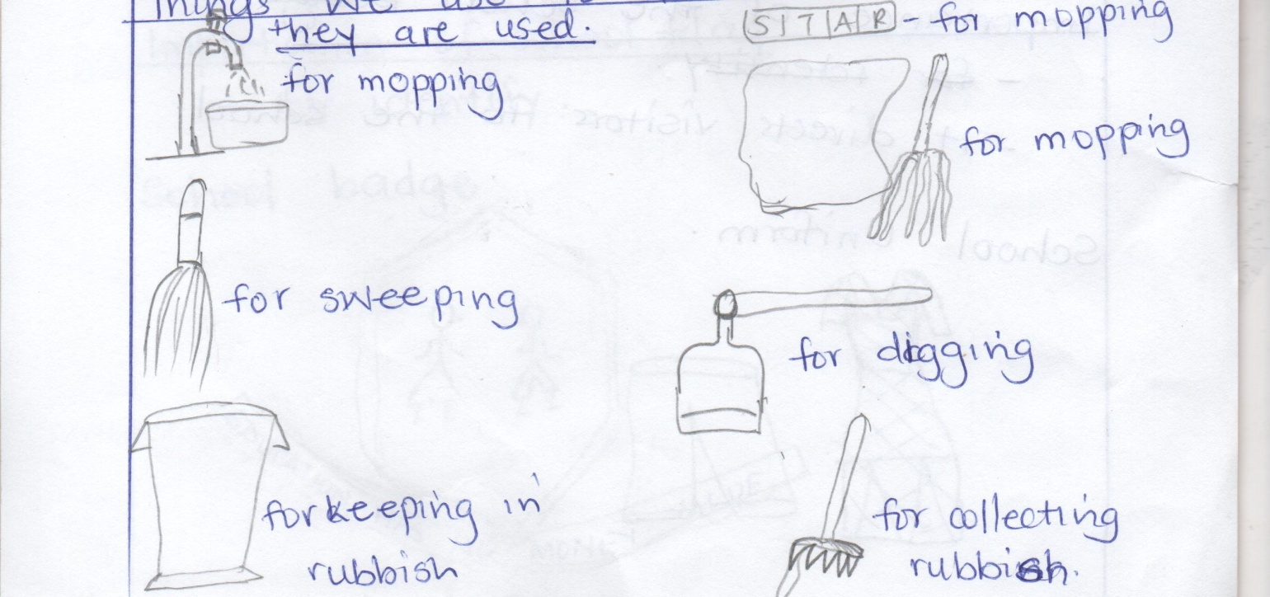Things we use to clean the school and how they are used.*

***Why we keep our school clean****.*

* *To prevent bad smell.*
* *To keep ourselves clean.*
* *To prevent germs and diseases.*

***Needs of a school****.*

***A school needs many things like;***

* *books*
* *textbooks*
* *chalk*
* *utensils*
* *furniture*
* *buildings*
* *water*
* *uniforms*
* *computers*
* *play materials.*
* *wall clock*
* *vans*
* *play ground*
* *pencils*
* *labour*
* *food*
* *electricity*
* *money*
* *rulers*

*Sources of school needs*

* *parents - farms*
* *markets - friend (donors)*
* *shop*
* *banks*

***School property***

*These are things that belong to the school*

* *Wall clock*
* *vans*
* *buildings*
* *chalk*
* *play materials*
* *utensils*
* *computers*
* *furniture*
* *textbooks*
* *utensils*
* *Garden tools.*
* *beds*

***Ways of caring for school property.***

* *By washing plates and cups.*
* *By keeping textbooks in shelves.*
* *By dusting tables.*
* *By cleaning classrooms*
* *By repairing vehicles.*
* *By repairing computers.*
* *By cleaning garden tools after use.*
* *By keeping garden tools in a store after use.*

***Personal property****.*

*These are things that belong to a particular person.*

*Examples include;*

* *bags, books, pens, pencils,. mattresses, books, uniforms, bedsheets, rubbers.*

*Caring for personal property.*

* *By keeping books in shelves.*
* *By washing uniforms and bedsheets*
* *By keeping pencils in bags.*
* *By polishing shoes.*

*Neighbouring schools.*

*A neighbour is a person near me.*

*Neighbouring schools are schools near our school.*

*Examples of neighbouring schools.*

* *Sunlight P/s, Kampala Quality P/s, Serena P/s, Hajara p/s, etc*

*Safe ways to and from school.*

* *Moving in groups.*
* *Cross from the zebra crossing*
* *Do not play on the road*
* *Walk from the footpath*

*Ways of going to school;*

* *By car*
* *By a motorcycle On foot*
* *By a bus*

*Dangers on the way to school.*

* *Animals bites*
* *Knocked by a car*
* *Insect stings*
* *Mad people stone people.*
* *Falling off a tree*
* *Drowning*

*Causes of road accidents*

* *Playing on the road.*
* *Bad roads*
* *Over loading*
* *Untrained drivers*
* *Drunken drivers.*

*How to control road accidents.*

* *By not playing on the road.*
* *By following road signs*
* *By walking in a single line*
* *By crossing the road at the zebra crossing.*

*Road signs:*

*These are symbols put a long the road to guide road users.*

*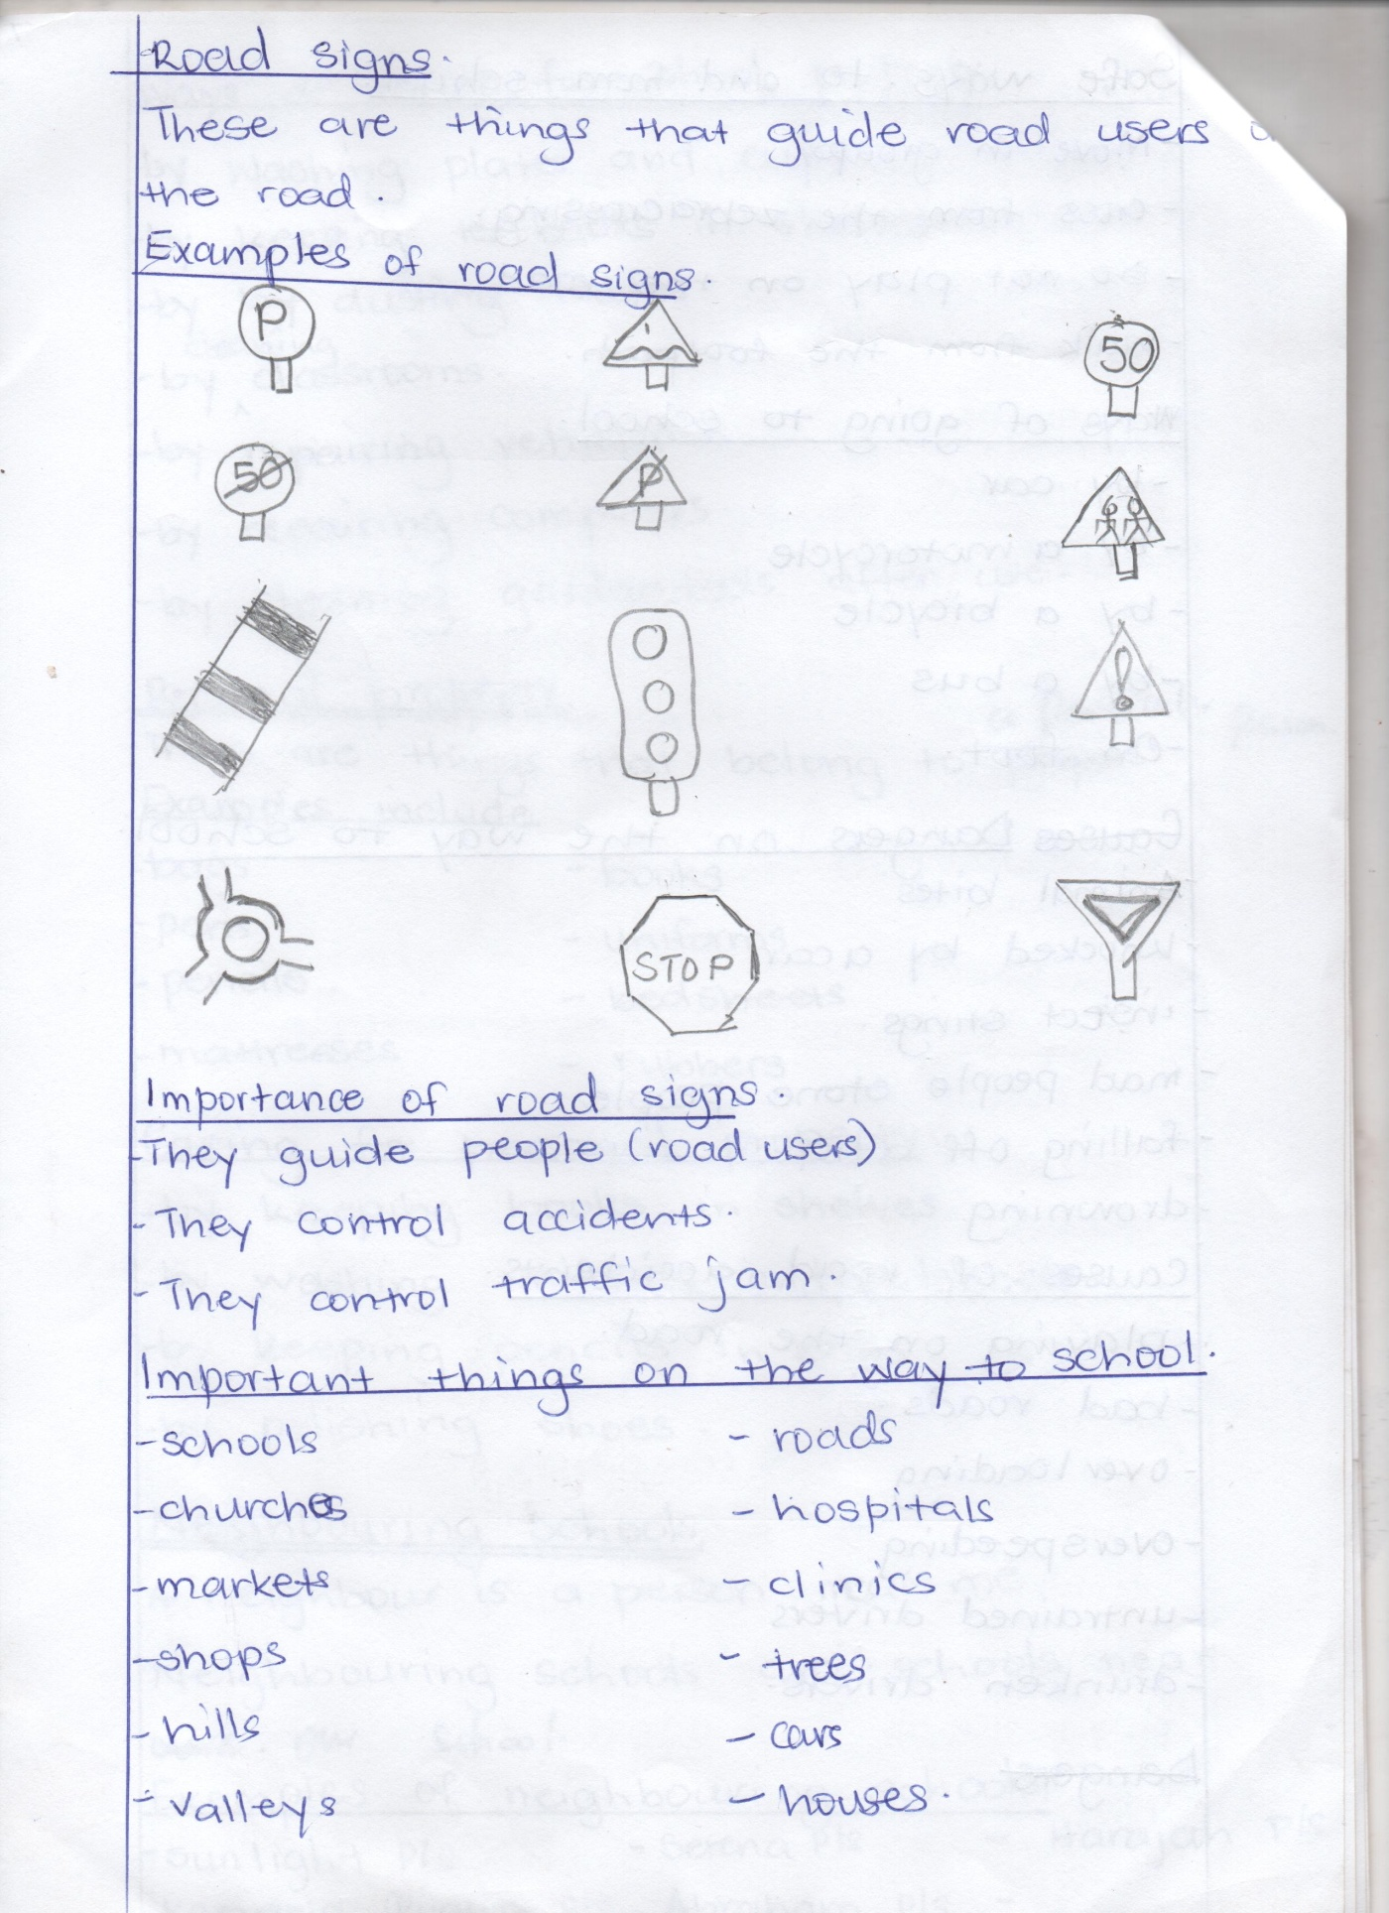Example of road signs.*

*parking humps ahead speed limit*

*end of speed limit no parking school children*

*danger ahead*

*zebra crossing traffic lights*

*round about give away*

*Importance of road signs.*

* *They guide people (road users)*
* *They control accidents*
* *They control traffic jam*

*Important things on the way to school*

* *Schools*
* *Churches*
* *markets*
* *shops*
* *hills*
* *valleys*
* *roads*
* *hospitals*
* *clinics*
* *trees*
* *houses*

***Theme: II our home***

*A home is a place where we live.*

*People at home.*

* *Father Niece cousin*
* *Mother nephew grandfather*
* *Sister uncle grand mother*
* *brother aunt*

*Father and mother start a home /family.*

*Types of families*

*A family is a group of people living together related by blood or marriage.*

* *A nuclear family is a family having father , mother and their children.*
* *An extended family is a family having father, mother, their children and other relatives.*

*Relatives in a family.*

* *aunt, grandmother, nephew, grandmother, uncle, niece, cousin*

*Roles of family members.*

*Father:*

* *Buys food*
* *buys clothes*
* *disciplines children*
* *pays family members*
* *pays house rent*

*Mother:*

* *cooks food.*
* *Washes clothes*
* *cleans the home*
* *buys food*
* *buys clothes*
* *disciplines children*

*Children:*

* *They fetch water.*
* *They help in cooking*
* *They wash utensils.*
* *They wash clothes*
* *They clean the home.*
* *They collect firewood.*

*Family relationships.*

* *Father and mother are my parents.*
* *The father of my parents in my grandfather*
* *The mother of my parents is grandmother.*
* *The sister of my parents is my aunt.*
* *The brother of my parents is my uncle.*
* *The child of my uncle/aunt is my cousin.*
* *The son of my brother/sister is my nephew.*
* *The daughter of my brother /sister is my niece.*

*Wrong people at home.*

*Rapists - abductors*

*Kinappers - defiles*

*Murderers - drunkards*

*Smokers*

*thieves*

*Bad behaviour done at home.*

* *Stealing*
* *Fighting*
* *Quarrelling*
* *Smoking*
* *Stoning*
* *Burning property at home.*

*Activities done at home.*

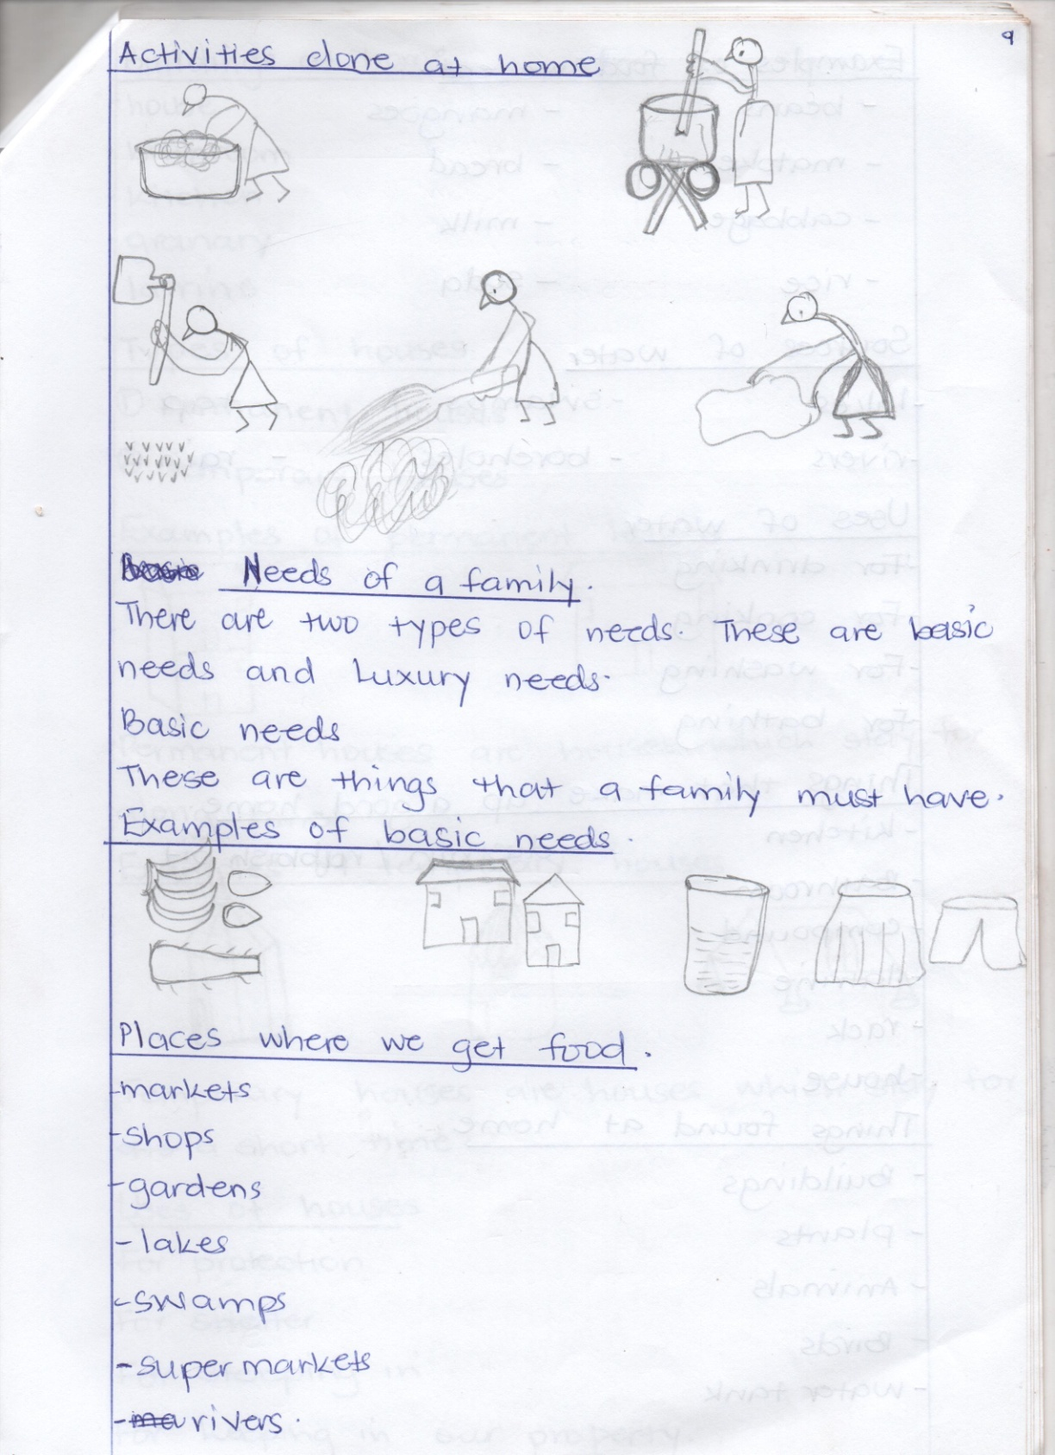

*washing cooking*

*digging*

*mopping*

*sweeping*

*Needs of a family.*

*There are two types of needs. These are basic needs and luxury needs.*

*Basic needs.*

*These are things that a family must have.*

*Examples of basic needs.*

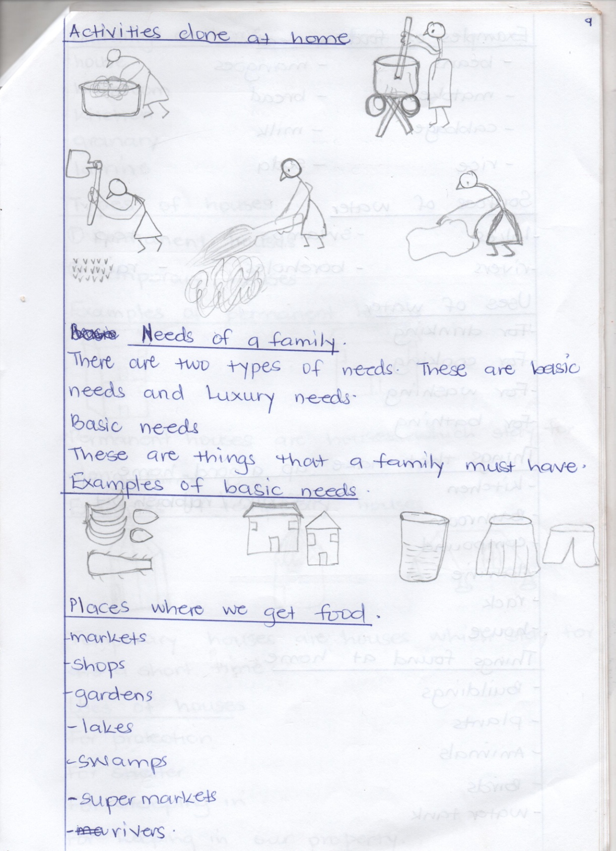

*food shelter water clothes*

*Places where we get food.*

* *Markets*
* *Shops*
* *Gardens*
* *Lakes*
* *Swamps*
* *Super markets*
* *Rivers*

*Examples of food we eat.*

* *beans , mangoes, matoke, bread, cabbage, milk, rice, soda.*

*Sources of water.*

* *Lakes*
* *rivers*
* *swamps*
* *boreholes*
* *tap*
* *rain*

*Uses of water.*

* *For drinking*
* *For cooking*
* *for washing*
* *For bathing*
* *For mopping*

*Thing that make up a good home.*

* *Kitchen*
* *Bathroom*
* *Compound*
* *Latrine/ toilet*
* *rack*
* *House*
* *Dustin/ rubbish pit*

*Things found at home*

* *Buildings*
* *Plants*
* *Animals*
* *Birds*
* *water tanks*

*Buildings at home.*

* *House*
* *Bathroom*
* *Kitchen*
* *granary*
* *Latrine*

*Types of houses*

* *Permanent houses*
* *Temporary houses*

*Examples of permanent houses*

* *Bungalow - Storeyed*

*Permanent houses are housed which stay for a long time.*

*Examples of temporary houses.*

* *Tent,*
* *kiosk*
* *Hut*
* *Unipot*

*Temporary houses are houses which stay for a short time.*

*Uses of houses.*

* *For protection*
* *For shelter*
* *For sleeping in.*
* *For keeping in our property.*
* *for business*
* *for warmth*

*Parts of a house.*

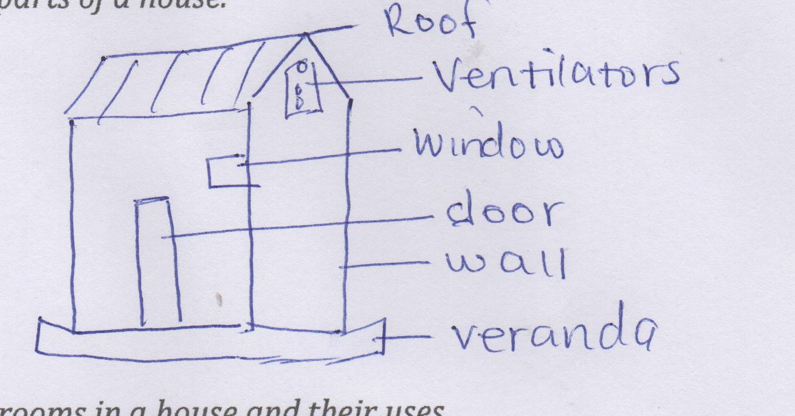

*Rooms in a house and their uses.*

* *Bedroom – For sleeping in.*
* *Kitchen - For cooking from.*
* *Latrine – For defecating in.*
* *Dining room – For having meals from.*
* *Sitting room - For sitting in.*
* *Store – For keeping things.*
* *Garage – For keeping in the car.*
* *Bathroom – For bathing from.*

***Things found in the house****.*

* *Bedroom- beds, bedsheets, blankets, clothes.*
* *Sitting room – Mats, chairs, tables, cupboard, photographs, radio, flowers, television, table cloths, wall-clocks.*
* *Kitchen – cups, plates, saucepans, buckets, pot, charcoal, stove, spoons, forks, mortar, pestle, bowls, jugs, drying racks, cooker, bucket*
* *Latrine – Scrubbing brush, water, soap.*
* *Garage – Car, bicycle, motorcycle.*
* *Store – Food , charcoal, garden tools.*
* *Diningroom - Cupboard, fridge, chairs, table.*
* *Bathroom - sponge, basin, brush, soap, bucket, jerrycan, pegs, drying wire.*

***Caring for things in the house.***

* *By washing plates and cups.*
* *By keeping utensils in the cupboard.*
* *By washing clothes*
* *By repairing chairs.*
* *By dusting furniture in the house.*

***Building materials.***

*These are things used to build a house.*

*Types of building materials.*

*Modern building materials.*

*These are materials used to build strong houses.*

*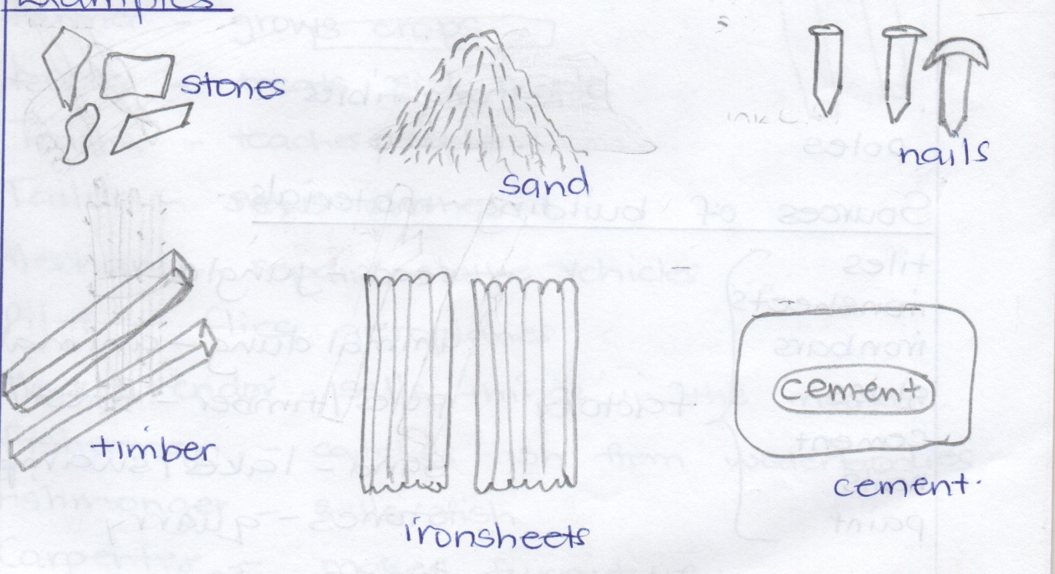Examples.*

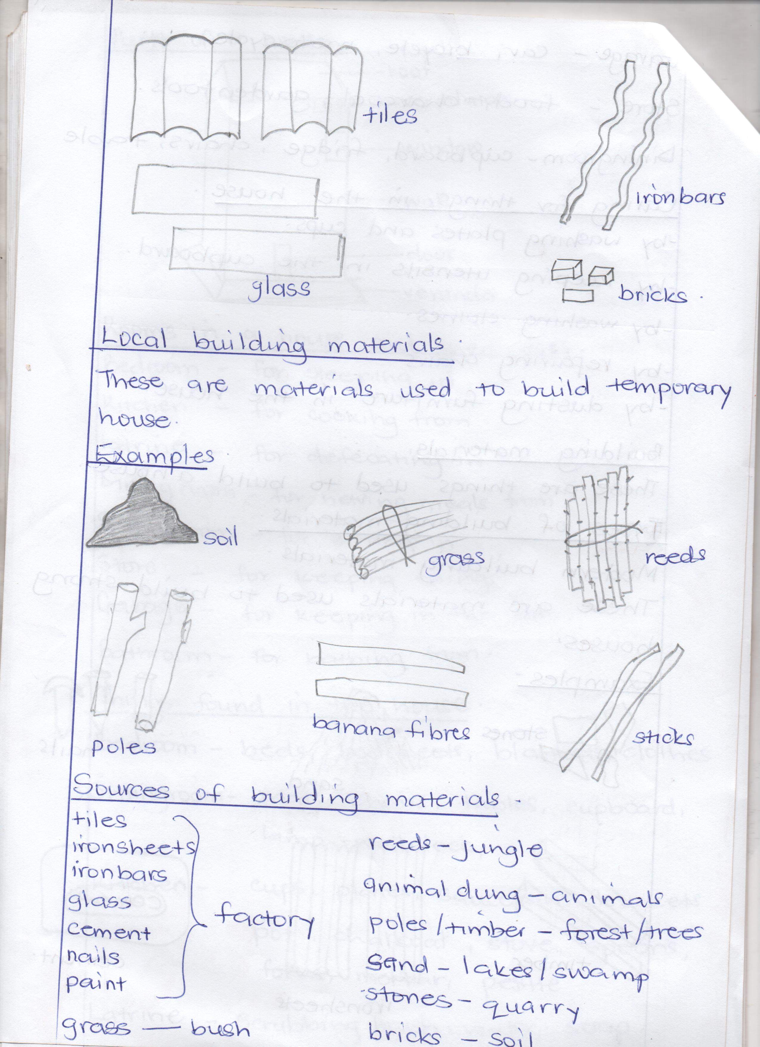

***Local building materials.***

*These are materials used to build temporary house.*

*Examples.*

***Sources of building materials.***

*tiles Reeds - jungle/ bush*

*ironsheets animals dung - animals*

*ironbars poles /timber – forest/ trees*

*glass factory sand – lakes / swamps/ rivers*

*cement stones - / quarry*

*nails bricks – soil.*

*paint*

*grass – bush*

***THEME III: OUR COMMUNITY:***

*A community is a group of people living or working together.*

*Examples of communities.*

* *Market community, Church community, Mosque community,*
* *Bank community, garage community, home community, village community*
* *School community, town community,Police community*
* *Hospital community*

*People in the community and their occupation.*

* *Barber – cuts people’s hair.*
* *Cobbler – repairs shoes.*
* *Farmer – grows crops and keeps animals.*
* *Doctor – treats people.*
* *Teacher – teaches people.*
* *Tailor – sews clothes.*
* *Mechanic – repairs vehicles.*
* *Pilot – Flies aeroplanes.*
* *Market vendor - sells things in the market.*
* *Fisherman – catches fish from water bodies.*
* *Fishmonger – sells fish.*
* *Carpenter – makes furniture.*
* *Priest – Leads prayers in church*
* *Imam- Leads prayers in the mosque*
* *Policeman – Keeps law and order*
* *Nurse – cares for sick people*
* *Banker – gives out money in the bank.*
* *Shopkeeper – sells things in the shop.*
* *Butcher – sells meat.*
* *Chef – cooks food in the hotel.*

***People in the community and their places of work.***

* *Priest - church*
* *Imam – mosque*
* *Policeman – police station*
* *Nurse*
* *Doctor hospital*
* *Banker - bank*
* *shopkeeper - shop*
* *butcher – butcher’s*
* *chef - hotel*
* *barber - barber’s*
* *cobbler - workshop*
* *farmer - farm*
* *Teacher – school*
* *Pilot – airport*
* *Mechanic - garage*
* *Carpenter - workshop*
* *Market vendor – market*
* *Grocer – grocer’s*

***Activities done in the community.***

* *Fishing, keeping cattle, farming , trading, building, washing, mining, carpentry, repairing vehicles, transportation.*

***Important places in the community.***

* *School, hospital, post office, radio station. market, church, mosque, bank, police station, airport, shop, garage, recreation centre, farm.*

**TERM II& III**

Theme: weather

Sub-theme

* Types of weather
* Elements of weather
* Uses of weather elements
* Dangers of weather makers
* Things used to protect ourselves from bad weather.
* Ways of protecting ourselves from bad weather.
* Activities done in each type of weather.
* Types of seasons
* Activities for different seasons.
* Garden tools
* Uses of garden tools.

Theme 2 : Our transport

Sub themes:

* Types of transport
* Means of transport
* People who operate transport means.
* Places where transport means are found / parked.
* Importance of transport
* Road safety
* Causes of road accidents
* Ways of controlling road accidents
* Effects of accidents
* Road signs
* Importance of road signs
* Road users

Theme 3: Things we make.

Sub themes:

* Thing we make at home
* Things we make at school
* Raw materials used to make things
* Things we make from different materials.
* Sources of raw materials used to make things
* Importance of things we make.

Term III

Theme 1: Peace and security

Sub themes:

* People who keep peace and security
* Examples of religious leaders.
* Roles of people who keep peace and security
* Factors that promote peace and security in our homes
* causes of insecurity in our homes
* Factors that promote peace and security in our school.
* Causes of insecurity at school
* Effects of insecurity
* Importance of insecurity.
* Things used to keep peace and security.

**TERM II & III**

THEME 1: WEATHER.

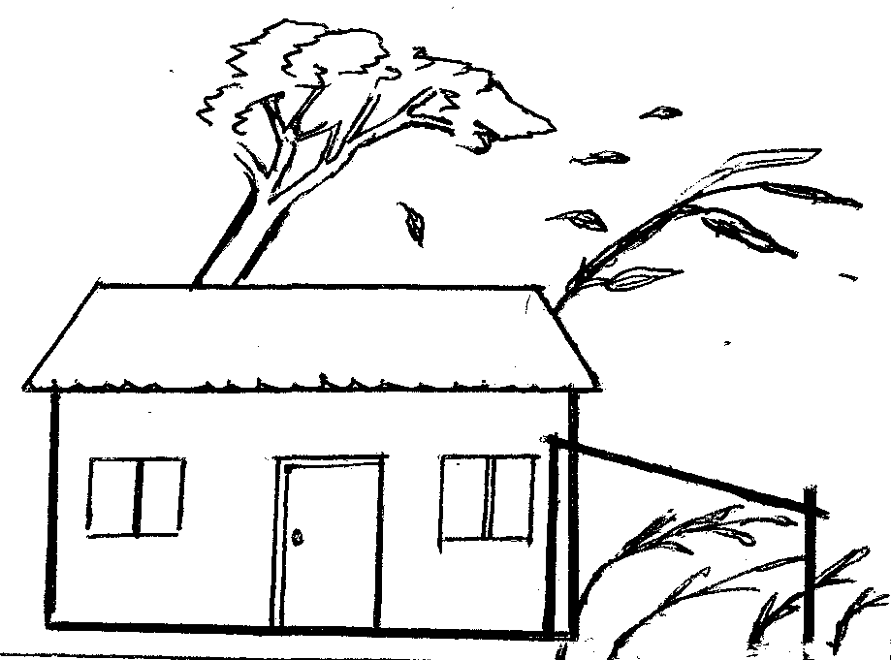Weather is the condition of atmosphere at a given time.

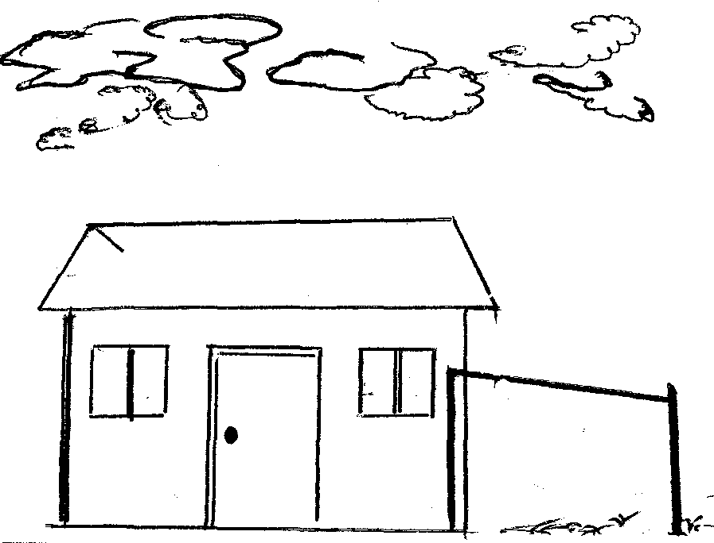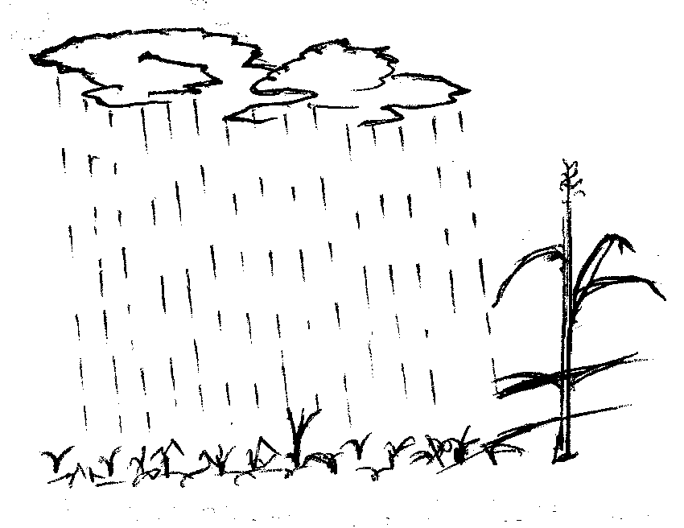Types of weather.

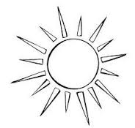 Windy

rainy Cloudy

Sunny

**Elements of weather**.

These are things that make up weather. They can also be called factors, aspects or weather makers.

Examples include.

* Wind
* rain
* cloudcover
* sunshine
* humidity
* temperature
* air pressure

Uses of weather elements

wind:

Wind is moving air.

Uses of wind.

* It takes away bad smell.
* It pollinates flowers
* It flies kites
* It drives windmills
* It helps boats to move on water
* It dries clothes
* It helps in winnowing
* It supports burning.
* It flies balloons.

**Dangers of too much wind**.

* It causes accidents
* It raises dust
* It spreads diseases
* It destroys houses
* It spoils crops
* It breaks trees
* It breaks bridges

**Rain:**

**Rain is the main natural source of water.**

**Uses of rain.**

* It gives us water
* It makes the soil soft
* It helps plants to grow
* It reduces dust
* It adds water into water bodies.

**Places where rain water goes**.

* ponds, soil, tanks, wells, rivers, swamps, lakes, swimming pools.

**Dangers of too much rain.**

* It spreads diseases
* It spoils houses
* It destroys crops
* It wets our property
* It causes floods
* It makes roads slippery
* It kills people and animals.
* It causes accidents
* It causes soil erosion
* It leads to land slides

Sources of water.

* lake
* borehole
* rivers
* taps
* wells
* tanks

**Clouds**

**Examples of clouds**

* Nimbus clouds
* Stratus clouds
* Cumulus clouds
* Cumulo-nimbus clouds
* Cirrus clouds

The farthest clouds in the sky are the cirrus clouds

Nimbus clouds give us rain.

Uses of clouds.

* They give us rain.
* They protect us from direct sunshine
* They make the weather cool.

Dangers of clouds

* They cause rain storm
* They cause lightning
* They cause air accidents

**Sunshine.**

The sun is the main natural source of heat and light. It raises from East and sets in the west.

Uses of sunshine.

* We get vitamin D
* It gives us warmth
* It gives us light
* It dries small fish
* It dries clothes
* It dries seeds
* It dries ready crops

Dangers of too much sunshine

* It spoils eyes
* It makes the soil hard
* It causes drought
* It causes famine
* It dries water bodies
* It kills animals
* It dries young crops
* It causes too much heat

Things used to protect ourselves from bad weather.

Rainy weather Sunny weather

* gumboots - hat
* rain coat - cap
* umbrella - vest
* jacket - light clothes
* sweater - umbrella
* coat - sun glasses
* banana leaf

Windy weather Cloudy weather

* Sunglasses - Sweater, Jacket and Coat

Ways plants and animals protect themselves from bad weather.

Plants

* By mulching them.
* by watering them
* by planting trees
* by pruning them
* by terracing them

Animals

* by keeping them in shelter
* by giving them enough water
* by treating them
* by planting trees near their homes.

Activities done in each type of weather.

Rainy weather sunny weather

* planting - watering crops
* pruning - drying seeds
* harvesting water - drying clothes
* weeding - harvesting crops
* thinning

Windy weather

* winnowing
* drying clothes
* sailing boats
* flying kites
* flying balloons

Types of seasons

There are two seasons in Uganda. These are;

1. Dry season ii. Wet season

**Activities for different seasons**

**Dry season Wet season**

* Preparing land - harvesting water
* Watering plants - planting
* Drying seeds - digging
* Harvesting crops - weeding
* mulching - pruning
* Burning - thinning
* Digging - spraying

- Sowing seeds

**Garden tools and their uses.**

Hoe - for digging

Watering can - for watering crops

Wheel barrow - for carrying manure

Rake - For collecting rubbish

Axe - For cutting big trees

Panga - For cutting small trees.

Basket - For harvesting crops

Knife - For cutting , peeling, harvesting crops

Spade - For spreading manure

slasher - For slashing

sickle - For cutting grass

Forked hoe - For digging couch grass

Trowel - For transplanting seedlings.

How to look after garden tools.

* Keeping them in cool dry places
* Cleaning them well after use.

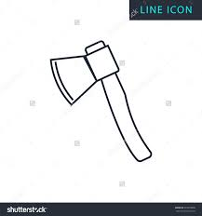Diagrams of tools used.

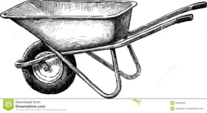 axe wheelbarrow

trowel

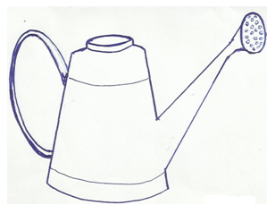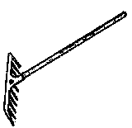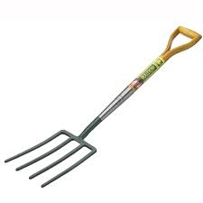

rake Watering can

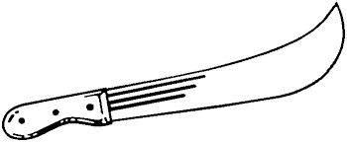forked hoe

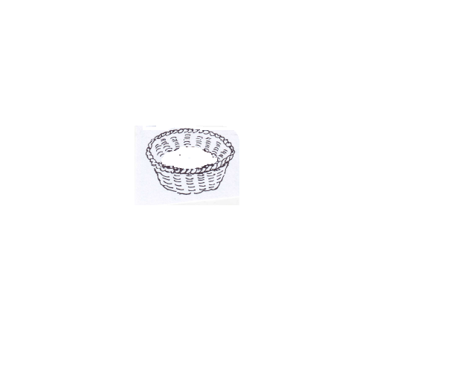

pangs basket

**Theme II: Our Transport:**

Transport is the movement of people and goods from one place to another.

**Types of transport.**

* Water transport
* Air transport
* Railway transport
* Road transport
* Pipeline transport

**Means of transport**

**Water transport**

* Ferry - Yacht
* Canoe - boat
* Ship

**Air transport**

* Aeroplane
* Helicopter
* Jet
* Rocket
* Parachute

Road transport

* car like; Benz, Toyata prado, Pickup, Regius
* bus
* lorry
* bicycles
* tractor
* motorcycle

Road users i.e.

* pedestrians
* drivers
* cyclists

A pedestrian is a person who walks along the road.

A driver is a person who drivers vehicles

A cyclists is a person who rides a bicycle.

People who operate different means of transport.

* Pilot - flies aeroplanes
* captain - sails ships
* Sailor - sails boats
* driver - Drives vehicles
* Engine driver - Drives trains
* Cyclist - Rides bicycles
* Motor cyclist - Rides motorcycles

Places where we find different means of transport

* Aeroplane
* Helicopter Air port
* Jet
* Ship - port
* boat - landing site
* bus - bus park (bus station)
* Taxi - Taxi park
* Train railway station

Importance of transport

* For carrying food
* For carrying clothes
* People earn money from transport.
* For carrying water
* For carrying animals
* For carrying building materials.
* It helps people move from one place to another.

**Road safety**

These are safe ways of using the road.

Examples:

* Cross at the zebra crossing.
* Do not cross the road in a corner.
* Do not run while crossing the road
* Walk in a single file.
* Do not play on the road.

An ambulance is used to carry sick people to the hospital.

Causes of accidents

* Playing on the road.
* Bad roads
* Over loading
* Speeding vehicles
* Untrained drivers
* Drunken drivers
* Careless drivers
* Driving vehicles under poor mechanical conditions.

Ways of controlling accidents

* Avoid playing on the road
* Avoid overloading
* Avoid speeding vehicles
* Drivers should be trained
* Repairing vehicles before driving them
* Bad roads should be repaired
* Do not drive while drunk
* Cross the road at the Zebra crossing.

Effects of accidents

* Death
* Lameness
* Poverty
* Loss of jobs
* Pain

**Theme III: Things we make**

Things we make using our hands are called crafts

Things we make at home.

* chairs - hat
* table - pot
* mortar - rope
* pestle - belt
* drum - doormat
* basket - cupboard
* mat - plate
* stool - charcoal stove
* bench - mingling stick
* bed

Things found in a house/

1. Kitchen:

* Charcoal stove - basket - cups
* mortar - spoons - pot
* pestle - plate - knife
* mingling stick - saucepans

1. Bedroom

* bed
* bed sheets
* closet
* pillow
* blankets

1. Sitting room

* mat
* chairs
* table
* cupboard
* carpet
* doormat

Things we make at school

* Bangles - ropes - shakers
* necklaces - hats - sweaters
* earrings - bags - cups
* dolls - table clothes - pots
* mats - basket - puppets
* kites - toys - scarves

Raw materials used to make things.

* sisal - wives - canes (njulu)
* banana fibres - clay soil - rubbers
* palm leaves - threads
* reeds - papyrus
* raffia - polythene bags
* straws - plastic
* bark cloth - rubber bands
* wood - seeds
* beads - metals
* skin/hides - papers

Things we make from different materials.

1. Clay

* pots
* plates
* cups
* charcoal stoves
* flower vases
* bricks
* tiles

1. Banana fibres

* mats
* dolls
* baskets
* bag
* ropes
* hats
* balls

1. Papyrus

* Mats
* baskets
* hat
* bags

1. Palm leaves

* mats
* hats
* brooms
* bags
* baskets

1. Skins / hides

* shoes - belts
* drums - balls

1. Sisal

* ropes
* sacks
* bags
* doormats

1. Wood

* chairs
* tables
* beds
* chalkboard rulers
* pencils
* toothpicks
* benches
* desks
* cupboards
* blackboard
* bookshelves

1. Threads

* Sweater
* table clothes
* bags
* bedcovers
* hats
* stocking

1. Straws

* mats
* table mats
* belt
* bag
* earrings

1. Bark cloth

* bags - door mats
* clothes - carpets
* table mats

1. Plastic

* cups - spoons - buckets
* plates - chairs - jugs
* jerrycans - forks - tins
* glasses - tables - pens
* basins - bottles - brushes

1. Wires

* toys
* hungers
* hooks
* earnings
* bangles
* necklaces

Sources of raw materials used to make, things

* wood - trees
* sisal - sisal plants
* skin/hides - animals
* Palm leaves - palm tree
* bark cloth - fiat tree
* clay - swamp
* threads - factory
* banana fibre - banana plants
* plastic - factory
* straws - factory

Importance of things we make.

* For playing with
* for domestic use
* for decoration
* For study purpose
* for sale

**TERM III, 2020**

**THEME I PEACE AND SECURITY**

Peace is living in harmony with others security is the state of being free from danger or threat.

People who keep peace and security

* L.D.U
* Police
* Teachers
* Religious leaders
* Parents
* Children
* LCs
* Army
* Elders
* Security personnel’s

Examples of religious leaders

* Bishops
* Reverand
* Pope
* Priest
* Imam
* Sheikh
* Muazzins

Roles of people who keep peace and security

Teachers

* They provide rules - They discipline children
* They guide children
* They counsel children

Parents

* They enforce discipline
* They guide children
* They counsel children
* They provide family basic needs.

Police

* They keep law and order
* They disciple people
* They protect people and property
* They guide and counsel people

Religious leaders

* They preach the word of God / Allah
* They guide people
* They counsel people

**Children**

* They obey rules
* They report wrong doers
* They guide others

**Factors that promote peace and security in our school**.

* Good relationship in a home
* health
* Love
* protection
* Obedience
* Respect

**Causes of insecurity in our homes**.

* Poor relationship in the home.
* Poverty - Fighting
* Diseases - Stealing
* Shortage of food - Indiscipline
* Violence - Beating
* Defilement
* Isolation
* Child neglect
* Death of parents

Factors that promote peace and security at home.

* School rules
* Caring for one another
* Interacting positively
* Observation of children’s rights and responsibilities

Causes of insecurity at school.

* Stealing
* Beating others
* Indiscipline
* Disobeying school rules
* Teasing
* Violence
* Fighting

Effects of insecurity

* death - hunger
* fear - divorce
* child abuse - disability
* trauma - homelessness
* dropping out of school - Loss of jobs
* fights
* poverty

Importance of peace and security

* Harmony
* love
* safety
* care
* unity
* respect
* freedom of speech

Things used to keep peace and security

